1.Scriplet Tag:

==========

The tag which contains the java code is called Scriplet tag.

There are two types of syntaxes for Scriplet tags.

Standard syntax:

===========

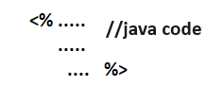

XML Syntax:

=========

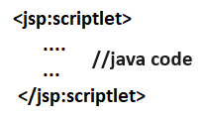

In early days of JSP launched , the xml booming was started in the market. So for jsp tags ,xml syntax was given along with standard syntax.

Point-1:

=====

* The variables declared in scriplet becomes local variables of _jspService(-,-) method in JES class.
* All implicit object of JSP are originally local objs of _jspService(-,-) method. So they can be used in scriplet also.

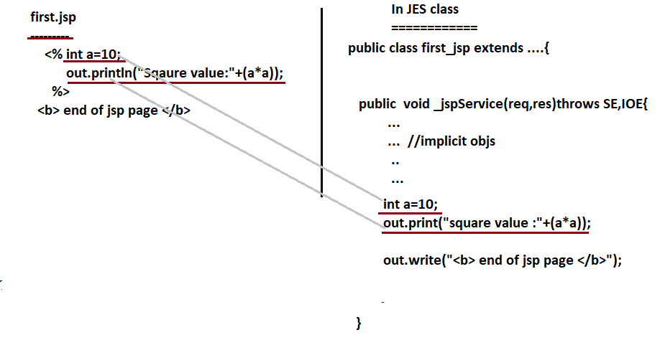

Point2:

=====

We can call method in scriplet but we can not define methods in scriplet as java does not support nested methods.

Eg:-

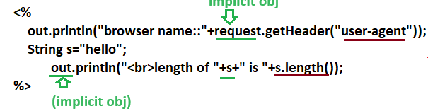

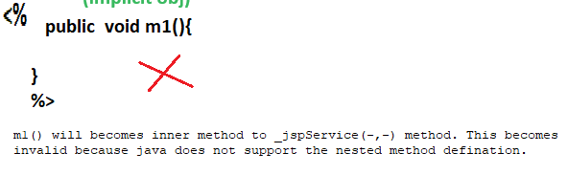

Two Cases combined in following example

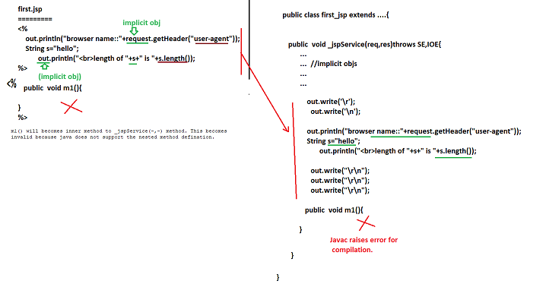

Point:3

=====

We can place class definition inside scriplet as java supports method level local class definitations.

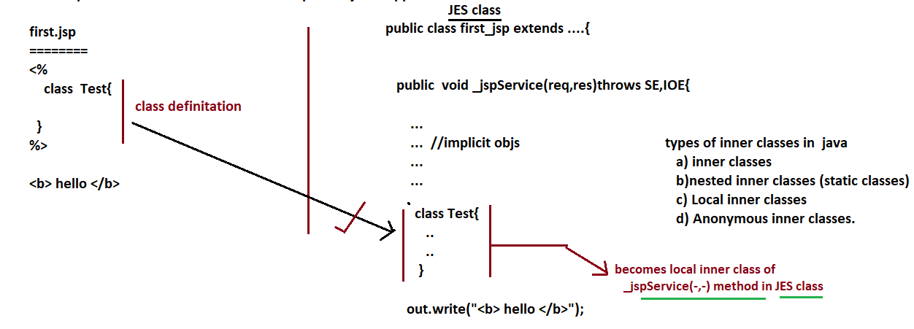The local inner class must be taken with out access modifiers (private, public, protected/default). The only abstract and final modifiers are allowed.

Point4:

=====

Java does not support local interfaces,we can say that we can not place interfaces in scriplet of jsp page.

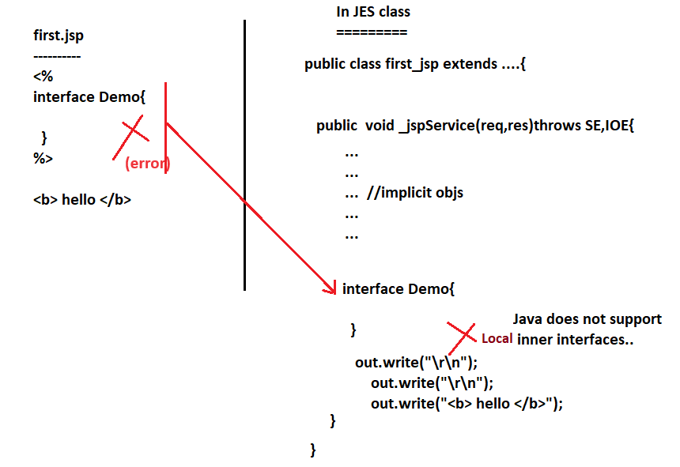

Point5:

=====

The Java code is placed in xml syntax:

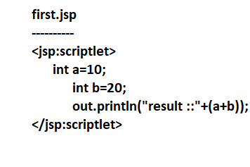

Drawback in XML tag syntax:

======= =============

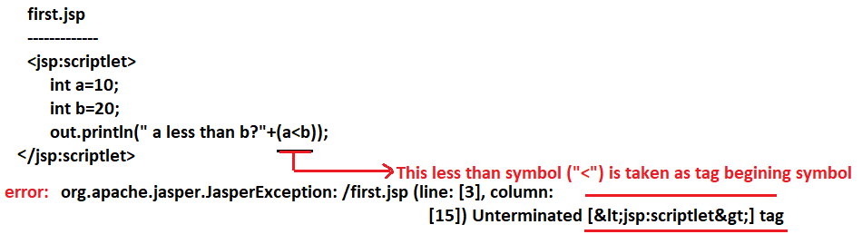

Solution1:: Using Standard syntax

======== =================

First.jsp

<%

Int a=10;

Int b=20;

Out.println(“a less than b?”+(a<b));

%>

Note:-1. Here the problem is escaped. But solution not given.

2. similar problem is not there with “>” symbol.

3. since the xml syntax is having multiple problems it is always recomanded to use standard syntax based jsp tags.

Solution2::

========

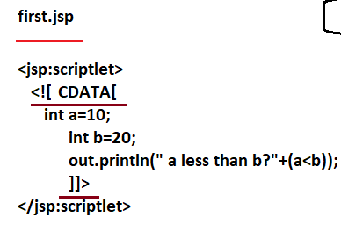

<![[CDATA[…]]> makes xml parser of jsp page compiler to take the given data as character data with out apply any xml meaning on it.

Point:6

======

In one jsp page we can place 0 or more scriplet tags either having xml syntax or having standard syntax or both syntaxes.

Nested scriplets are not allowed i.e we can not place scriplet tag inside another scriplet tag.

